**DOCUMENTATION OF KYAMUHUNGA UNIVERSITY**

**The navigation bar.**

This allows the user to move from one html page accessing he or she wants. It allows to fill the required the information and access his/her information.This entails options like home, online application, admission, registration, view results online, financial statement.

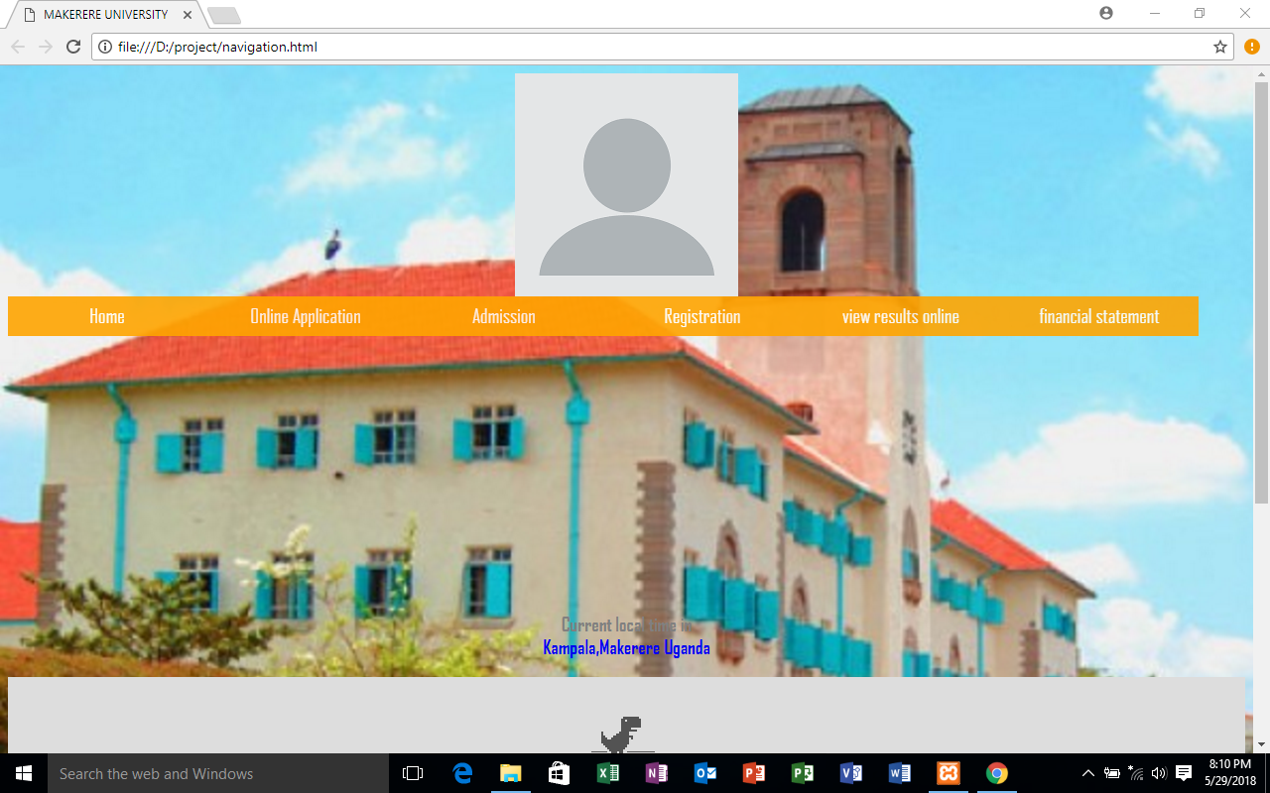

**THE REGISTER OPTION**

This designed to link the user being the student to where is to submit his details to the system.

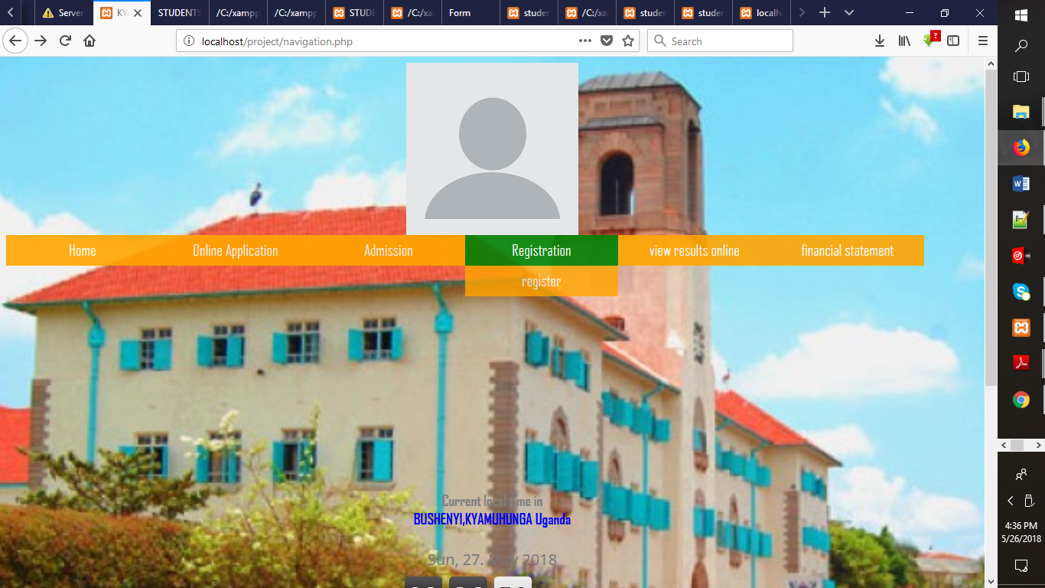

**LOG IN MODULE**

After being assigned a username and password whereby this is done by student basing on the system requirements.

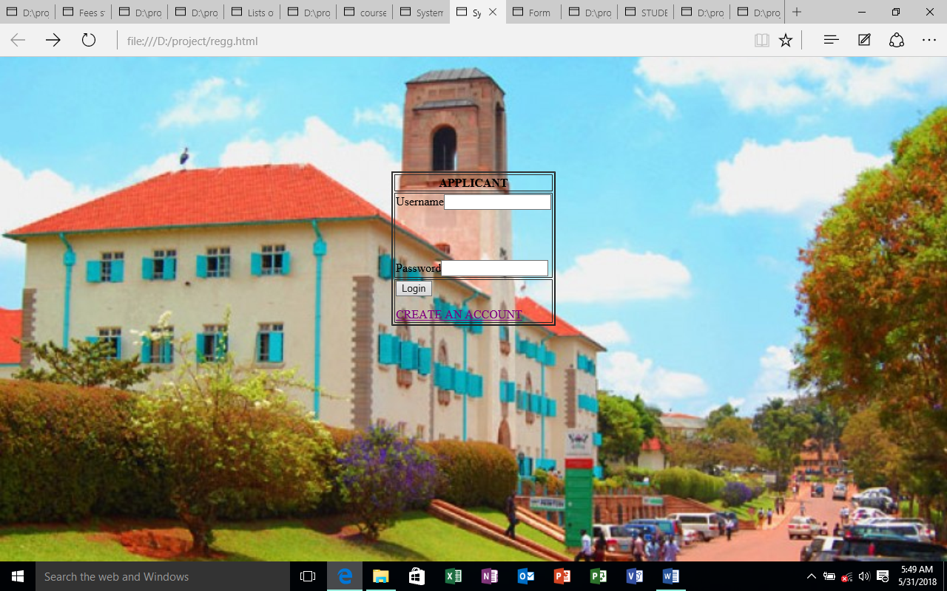

In regards to creation of a new account, one will just click on the create an account option and this will happen;

**Application portal**

This is designed to the student to fill in the required data so as to register for one’s preferred course. The information details the academic background of the student.

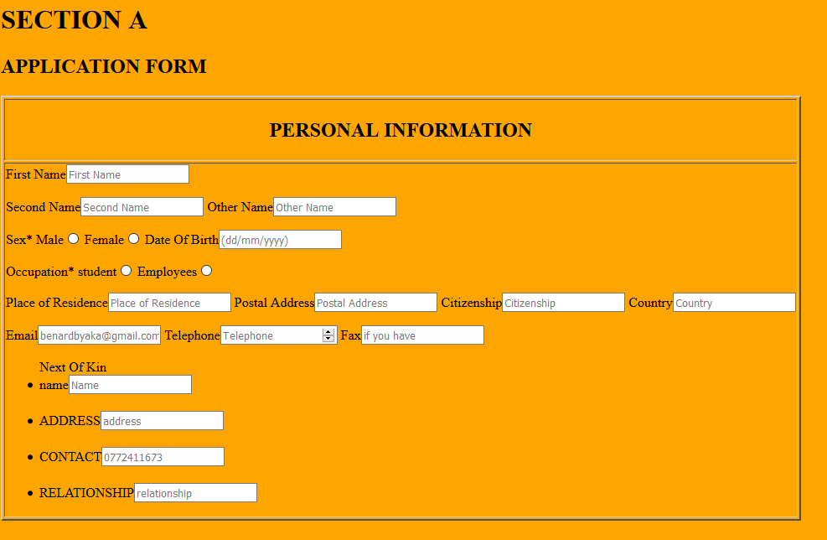

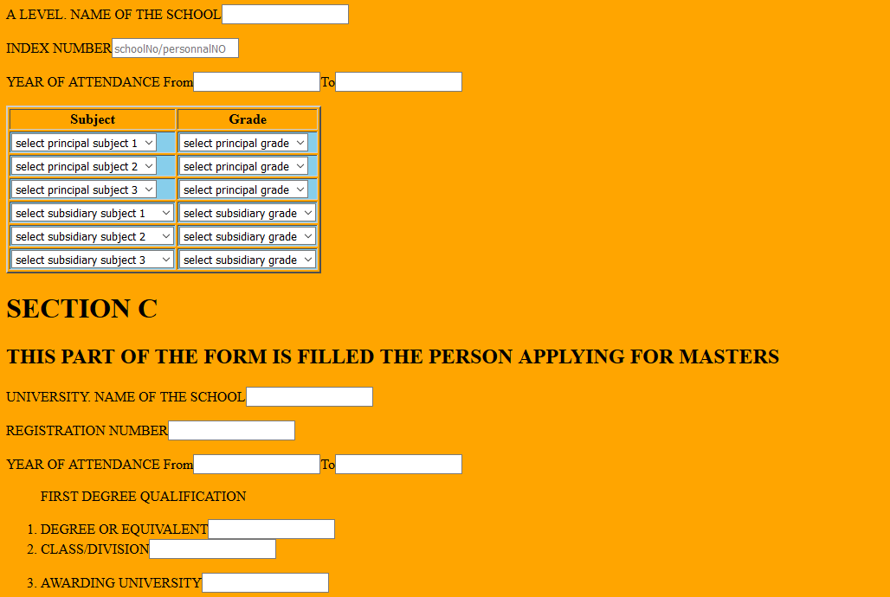





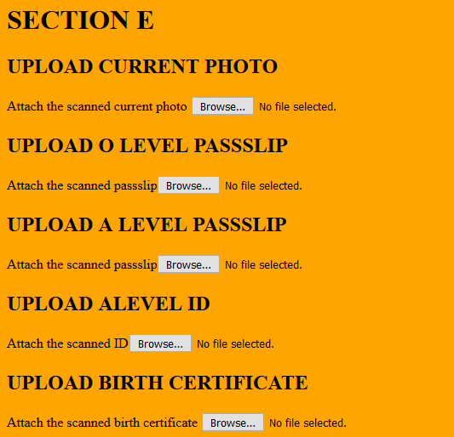

Fill in all the required fields in each of the tabs that follow i.e. **“Personal Information”**, **“academic information”**, **“”**, **“Documents”** and **“Declaration”**. A current tab will be marked as **“In Progress”**, a completed tab will be marked as **“Done”** and an unfilled tab will be marked as **“Pending”**. Please note that once you submit your application, you cannot make any changes to it.

After filling all fields, the applicant will be required to click on the apply to enable him details to be submitted to the database.

All uploaded documents have to be under **500KB** while your picture (passport photo) has to be under **100 KB**.  
**Tip**: Compress your document scans in a way that will keep their resolution good enough but file size under the stated limits.

After submitting your application on the last tab, please generate a bank-slip that you shall use to make payments at the bank of your choice from the bank(s) listed. Please note that the application process is only complete after the application fee has been paid. Write your application number on the bank-slip before making payments to the bank.

**CREATON OF USERNAME AND PASSWORD.**

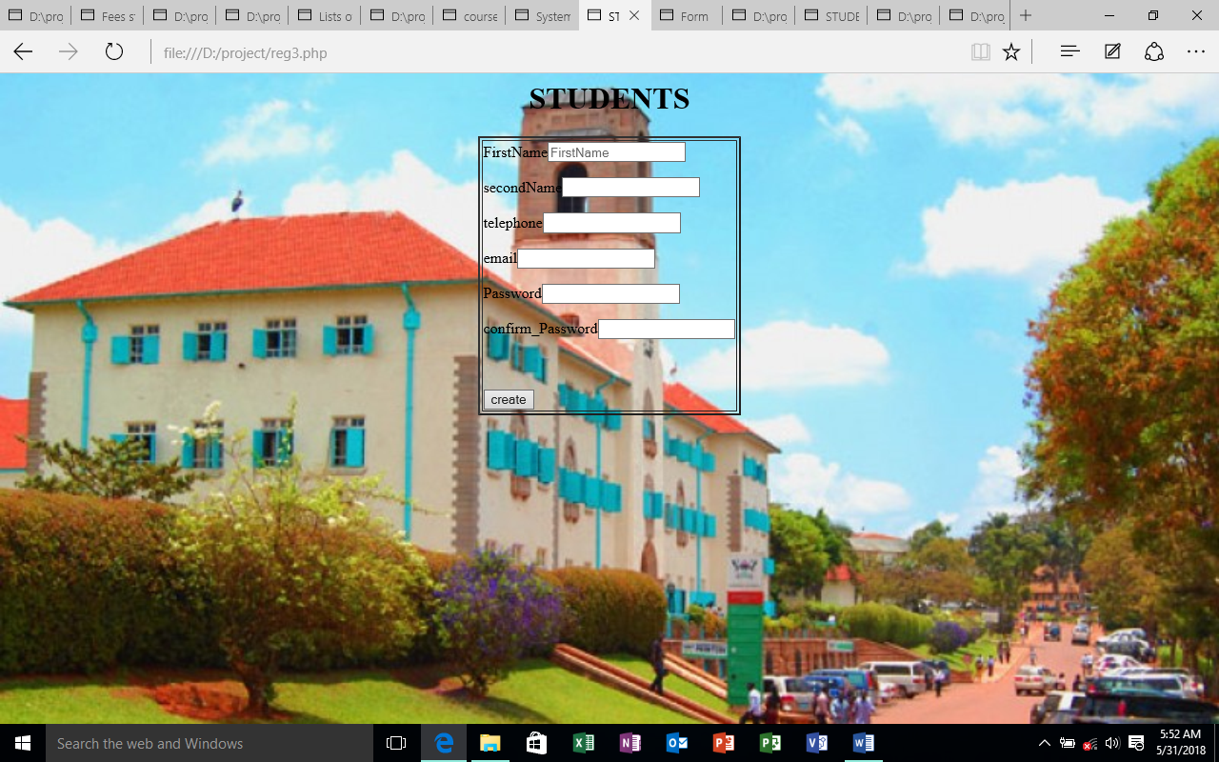

This allows the student form a new account in regards to the requirements of the system, as the system guides him/her on what is to be done.

In cases where were the student does not have an email address, he/she is to do as follows;

**How to Create an Email Address?**

Access a browser on an internet enabled computer.

Choose an email provider of your choice by going to one of the following URLs - Yahoo (<https://www.yahoo.com>), Gmail (<https://www.gmail.com>), Hotmail (<https://www.hotmail.com>) or any other provider of your choice

Click on create new account/signup button

Enter all the mandatory fields normally marked by a star (*)

Type in your username (Make sure it's relevant to your purpose)

Choose a secure and easy to remember password (Secure passwords typically have numbers, special characters, uppercase and lowercase alphabets)

Select your security question and answer. This will allow you to reset your password in case you forget it.

Verify your registration by typing the text you see in the captcha, if applicable.

Save to create your email account.

Login to your email account to confirm.

Please keep track of this email id and password as relevant information from the University system will be sent only to this email ID.

**THE HOME MODULE**

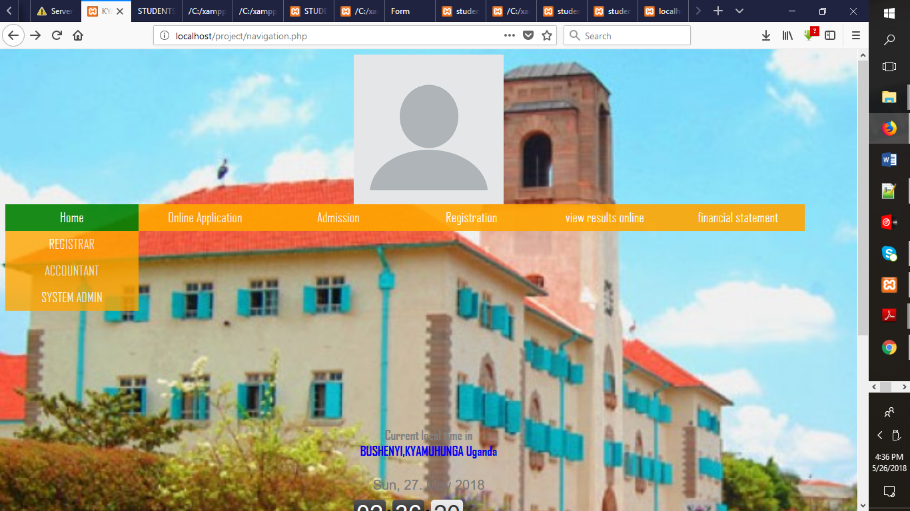

This is designated for entry of data on the part of those in charge of the registration, finance and the system administration.

Other options include;

**THE VIEW ONLINE TAB.**

Here the user is able to access his/her information.

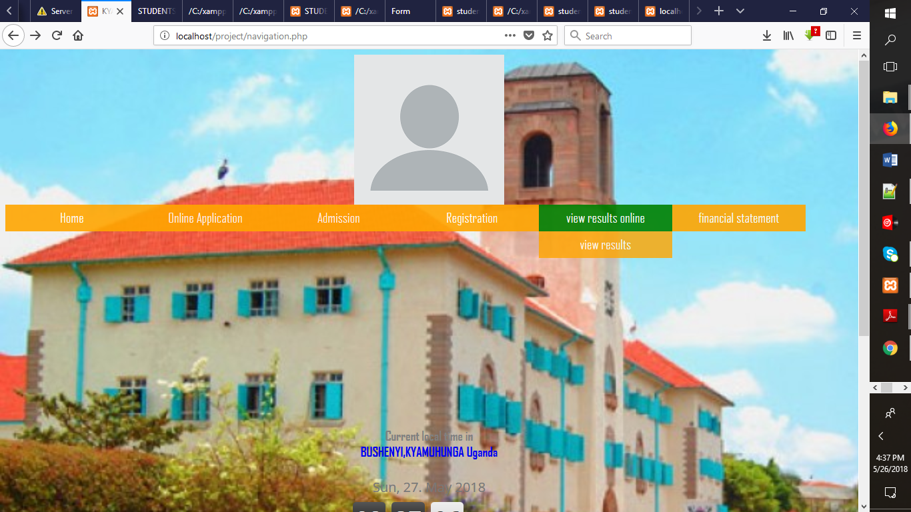

**THE ENTRY OF STUDENTS MARKS MODULE**

This module allows for entry of data by the system administer most especially the lecturer. This data is recorded into the database.

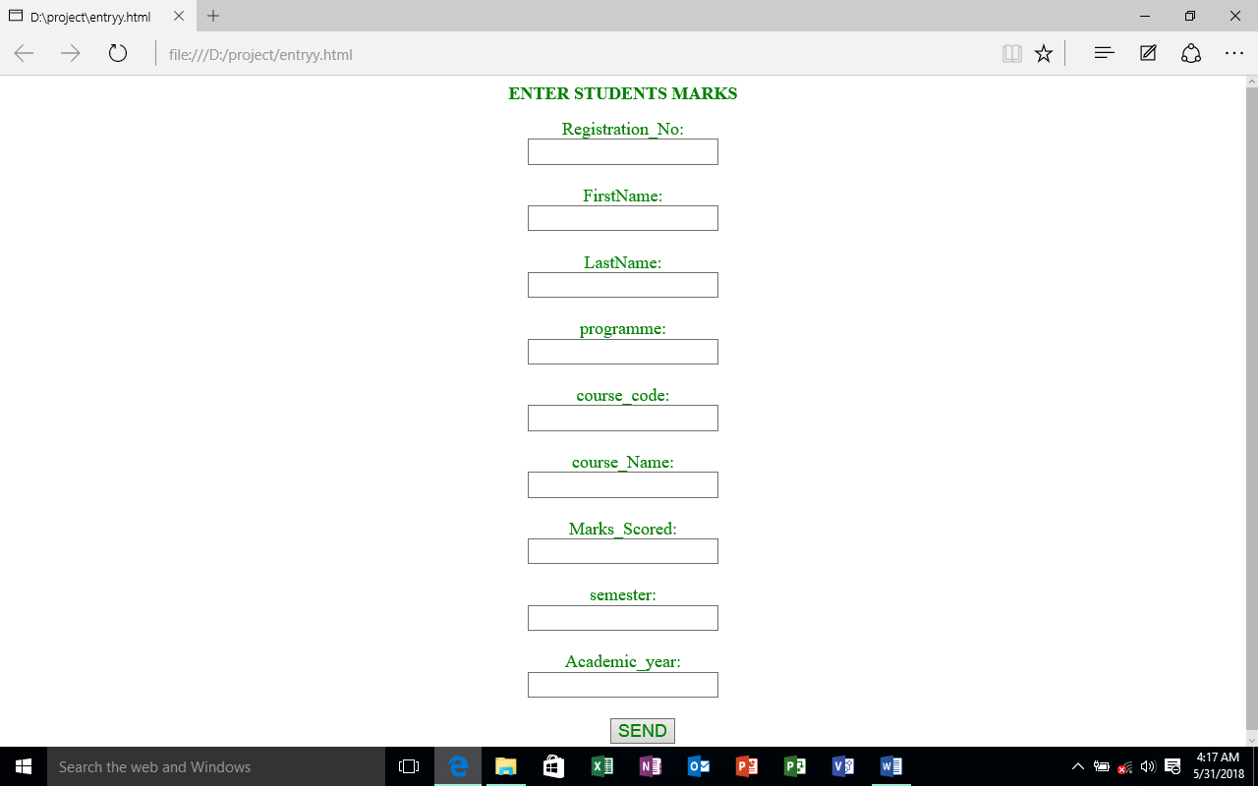

**THE REGISTERED STUDENTS MODULE**

After registration is completed, a registration number is generated for the student, allowing him/her to access his/her personal information by inputting the required information.

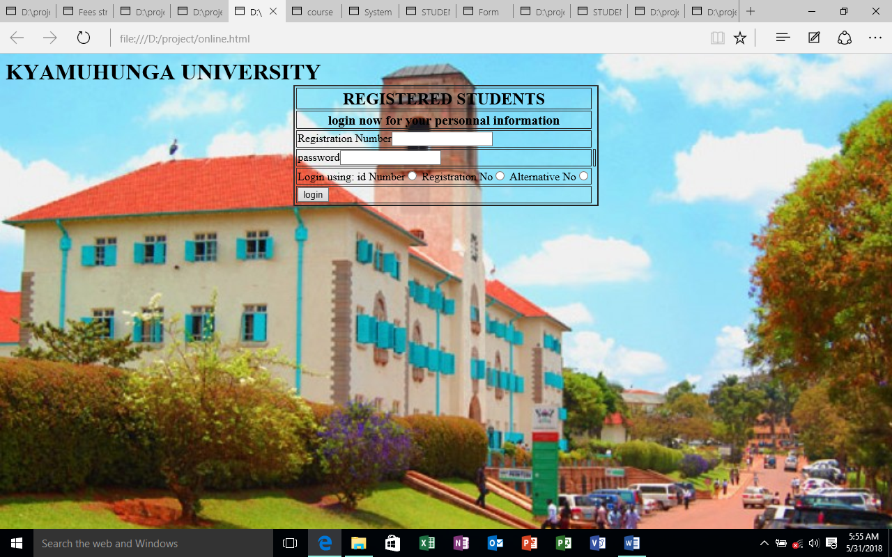

**LOGIN FOR OTHER PARTIES**

This is where the registrar, accountant and system administrator to enter the system and obtain the information they require.

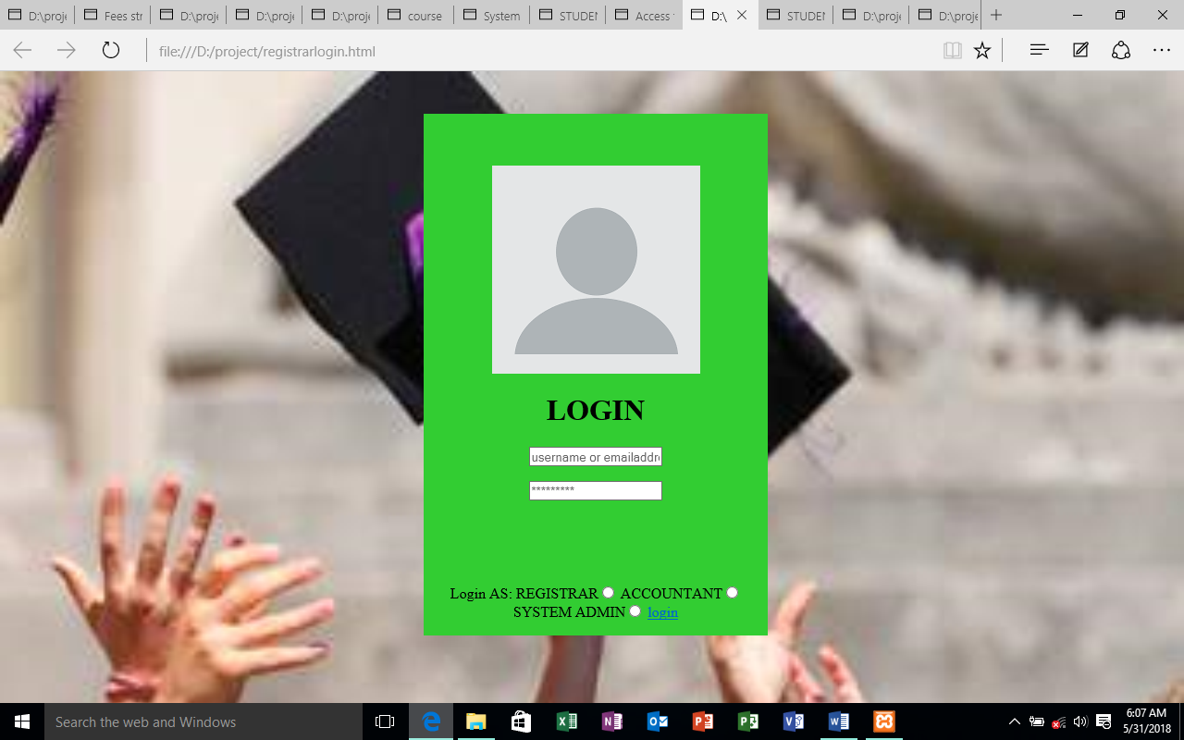

Which includes also;

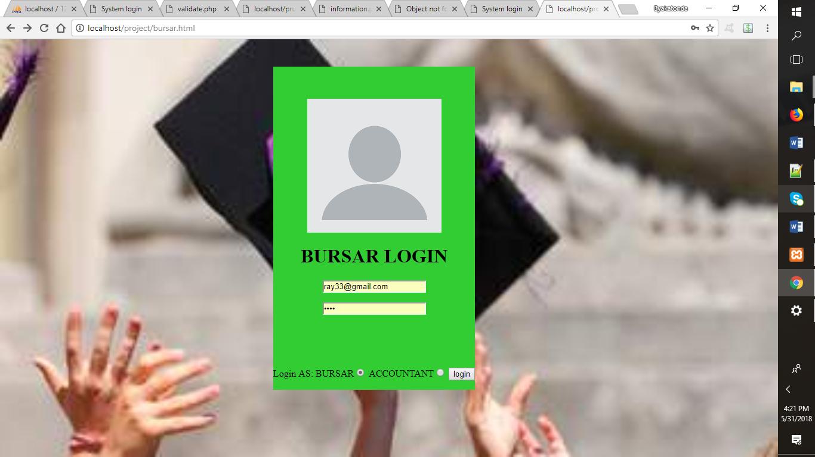

This is where the bursar monitors payments and the resultant output is as shown;

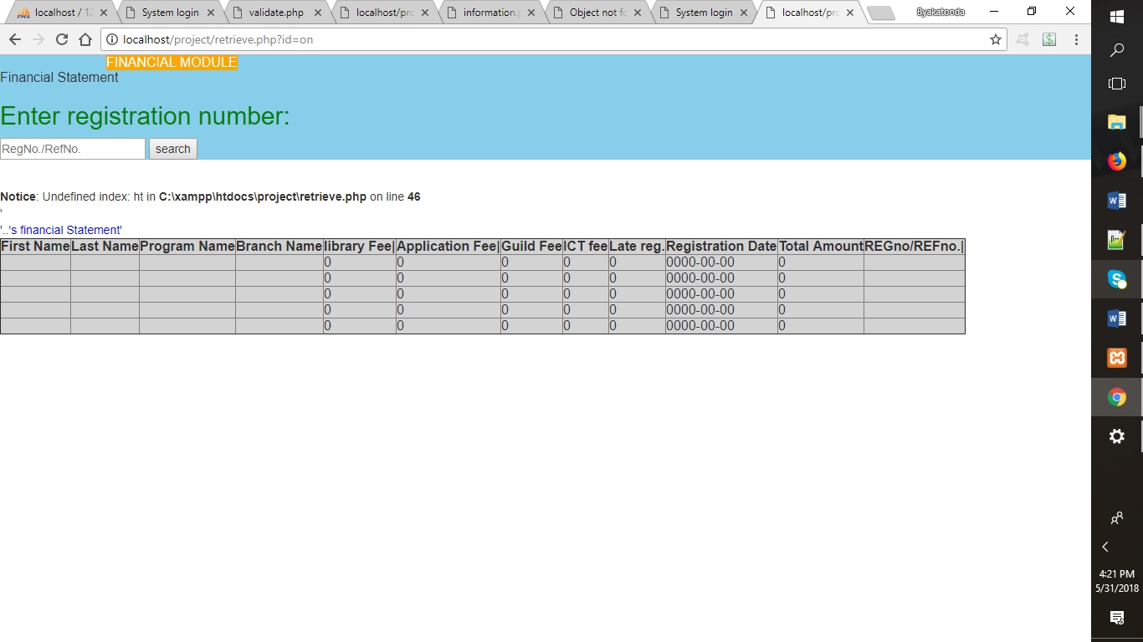

Here there is a detailed account of all payments to be made.

**THE ENTRY OF COURSES**

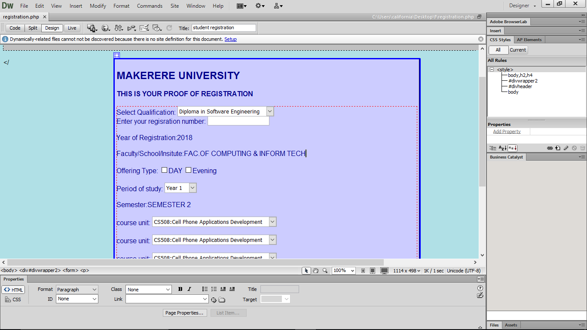

The records the selected courses into the database.

This takes into account the proof of registration whereby it notifies the system the course units selected and specifies the course to be studied for that particular period.

**The verification of payment**.

Here who have not met the minimum requirement are discarded by the system and left out or given a fine depending on the situation.

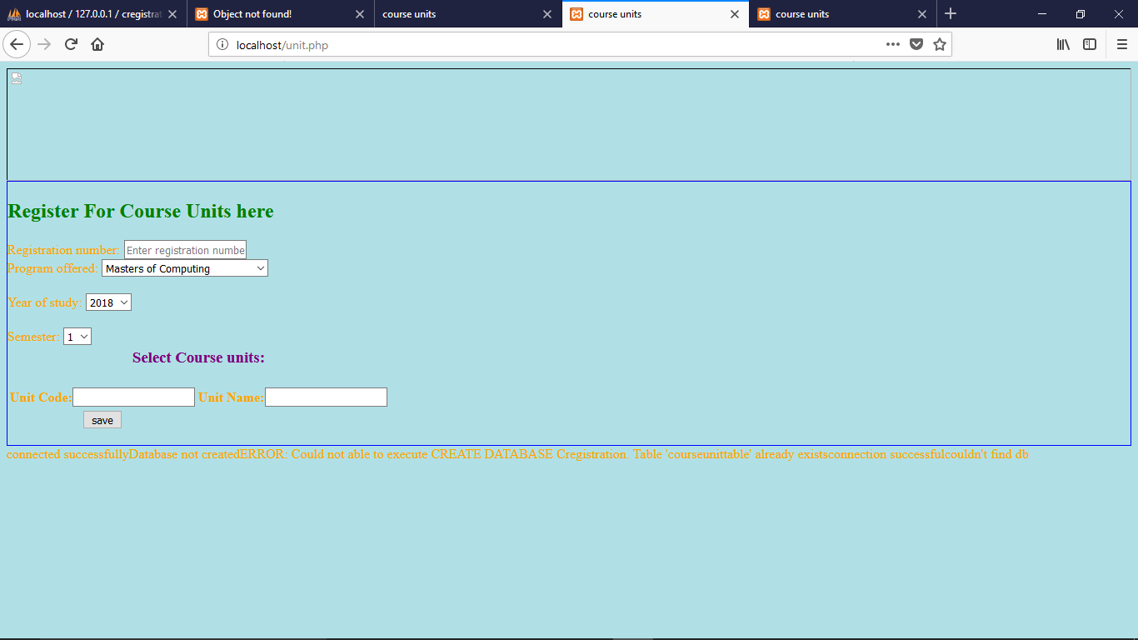

**Important to note:**

You will need a valid email address before you can use the online application portal. Create an email account if you don’t have one.

Please have scanned copies of your passport size photo, birth certificate, O and A Level pass slips and previous school ID and academic transcripts where necessary before you start filling your application

Once you pay the application fees, please login again to confirm that the application status has changed from **‘Application Submitted’** to **‘Application Completed’**. If otherwise, please contact the Academic Registrar’s Department, **Office 612**, Senate building or [helpme@acadreg.mak.ac.ug](mailto:helpme@acadreg.mak.ac.ug).

Do not share your application portal login details with anyone.

Make sure you logout and close browser window after filling application form.

**THE FINANCIAL STATEMENT MODULE.**

The basis of this is to allow those have registered to have an account the payment made to the bank for their registration.

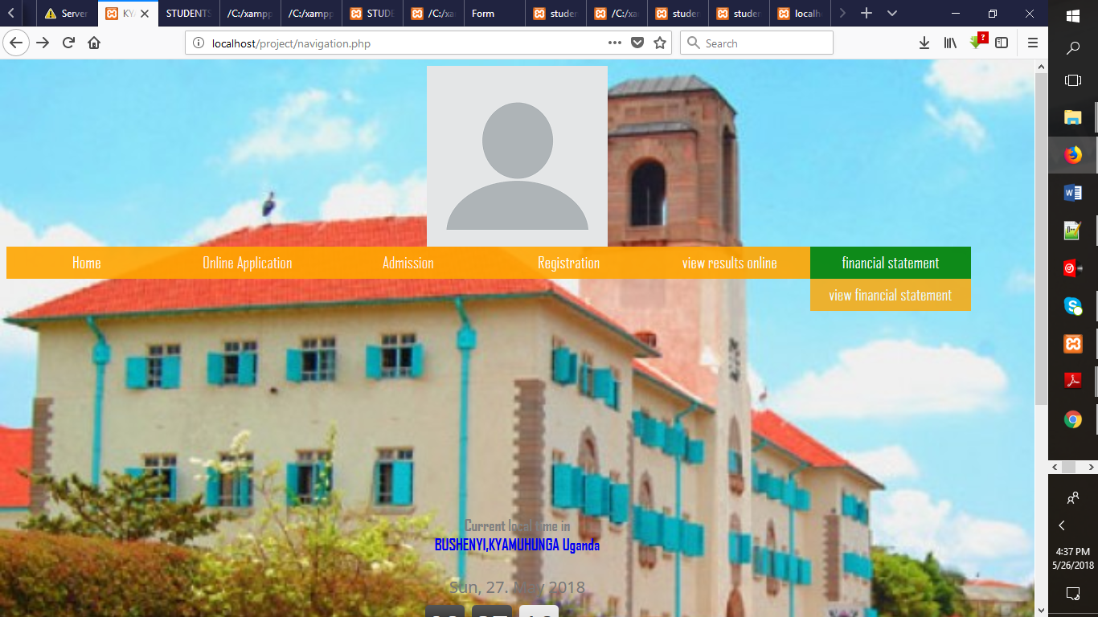

The output;

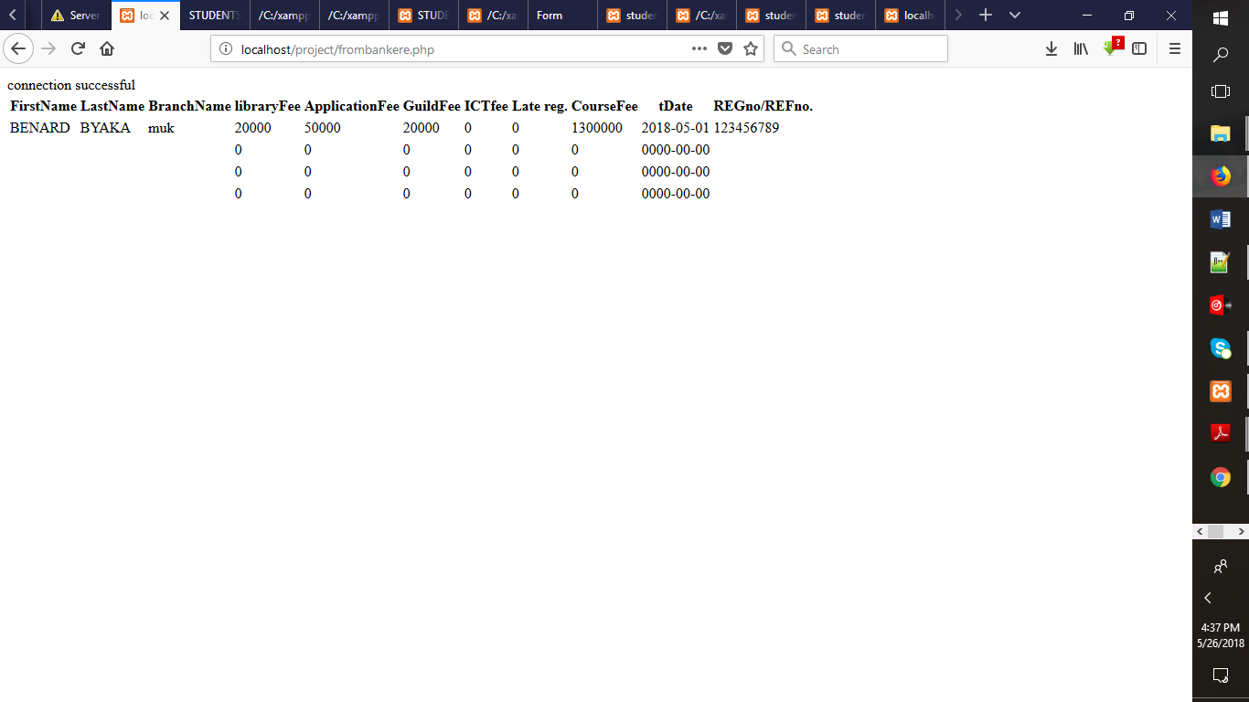

**THE DATBASE.**

All applicant information is stored in here to allow easy management of the system.

